**Ein Bild, das Text, Screenshot, Schrift, Reihe enthält.
**

**Supplementary Fig. 1:** Dot plot showing the feature profile of all annotated cell types including immune and non-immune cells in the analyzed murine lung data.

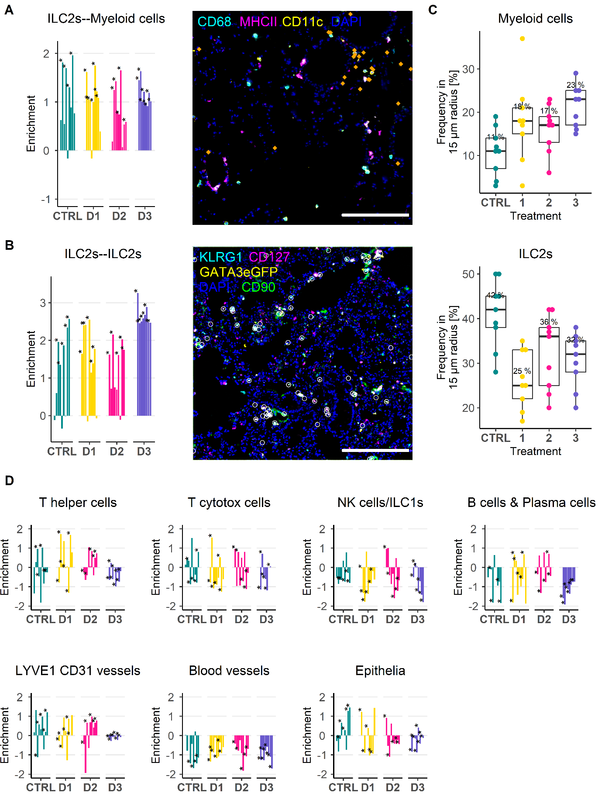

**Supplementary Fig. 2: (A)** Bar plot showing the results of the co-enrichment analysis of ILC2s and myeloid cells. Each bar represents one analyzed FOV. IF overlay stained for CD68 (Cyan), MHC II (Magenta), CD11c (Yellow), and DAPI (Blue), and with identified ILC2s depicted as dots (Orange). Scale bar represents 200 µm. Each dot represents one identified ILC2. **(B)** Bar plot showing the results of the co-enrichment analysis of ILC2s and ILC2s. **(C)** Box plot depicting the results of the CIN analysis of ILC2s of myeloid cells (upper) and ILC2s (lower). **(D)** Overview of the results of the co-enrichment analysis of ILC2s with other identified immune and non-immune cells.

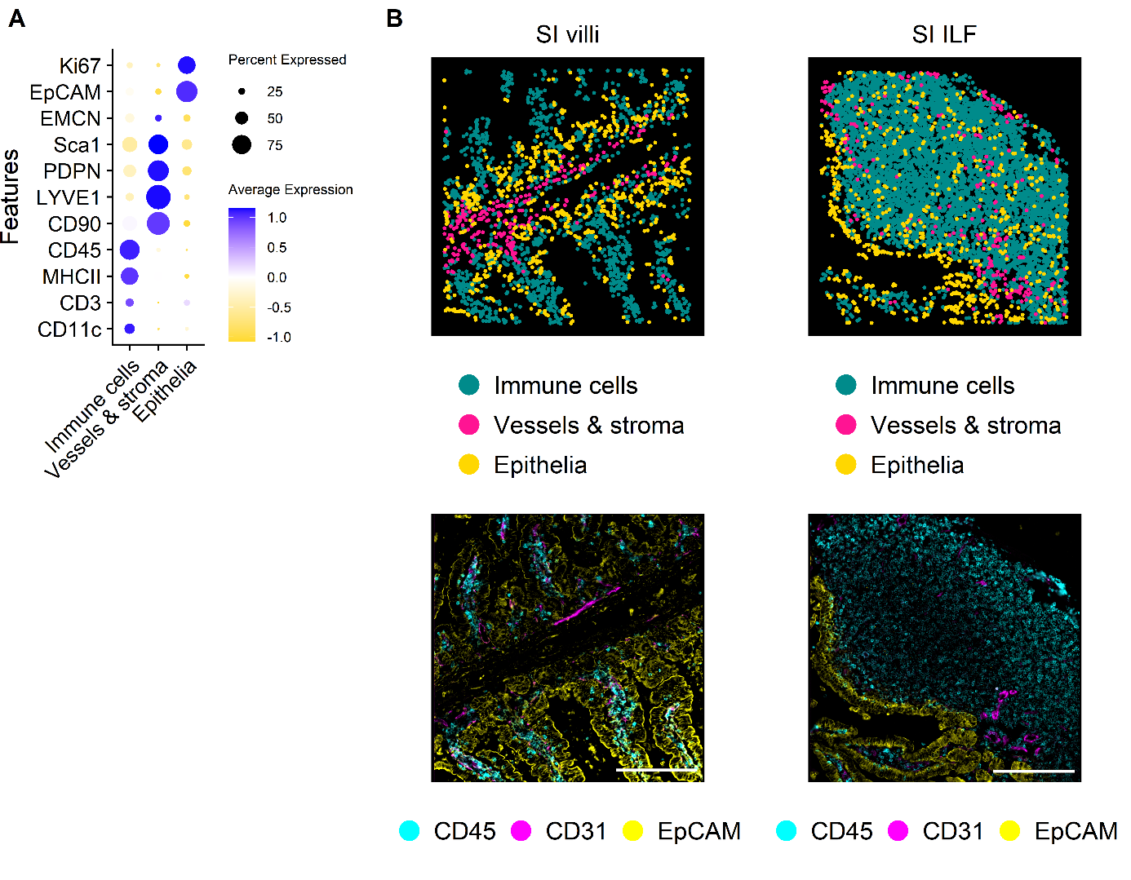

**Supplementary Fig. 3: (A)** Dot plot showing the feature profiles of the annotated major cell types of AL1 in murine SI tissue. **(B)** Visual validation of annotated cell types (Upper panel) and the respective IF overlays (Lower panel) in a representative FOV of SI villi (Left) and SI ILF (Right) tissue area. Depicted identified cell types are immune cells (Darkcyan), vessels & stroma (Pink) and epithelia (Gold). Overlay shows stainings of CD45 (Cyan), CD31 (Magenta), and EpCAM (Yellow). Scale bar represents 200 µm.

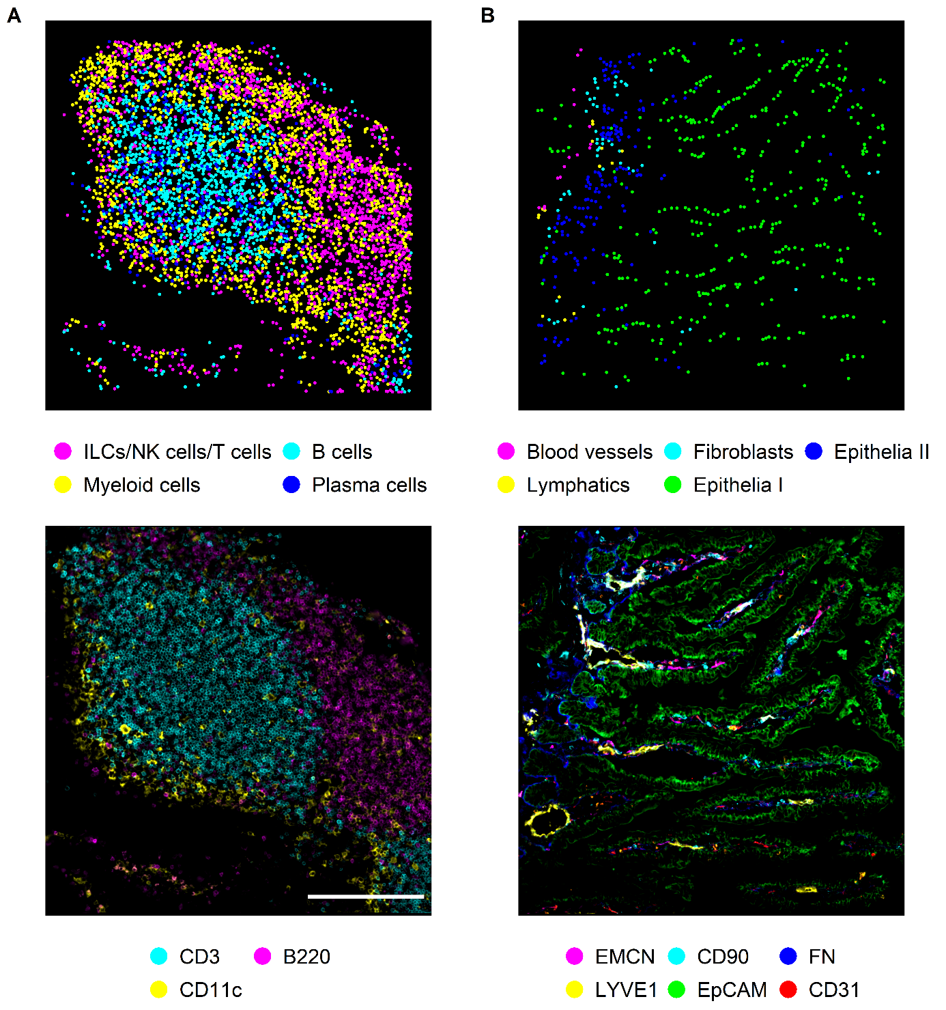

**Supplementary Fig. 4: (A)** Spatial plot of identified immune cell types of one representative FOV of murine SI and the respective IF overlay showing B220 (Cyan), CD3 (Magenta), and CD11c (Yellow). **(B)** Spatial plot of identified immune cell types of one representative FOV of murine SI and the respective IF overlay. Identified and depicted cell types are blood vessels (Magenta), fibroblasts (Cyan), lymphatics (Yellow), epithelia I cells (Green), and epithelia II cells (Blue). IF stainings overlayed are CD90.2 (Cyan), EMCN (Magenta), FN (Blue), EpCAM (Green), CD31 (Red), and LYVE1 (Yellow). Scale bar represents 200 µm.

**Supplementary Fig. 5: (A) (B) (C)** .

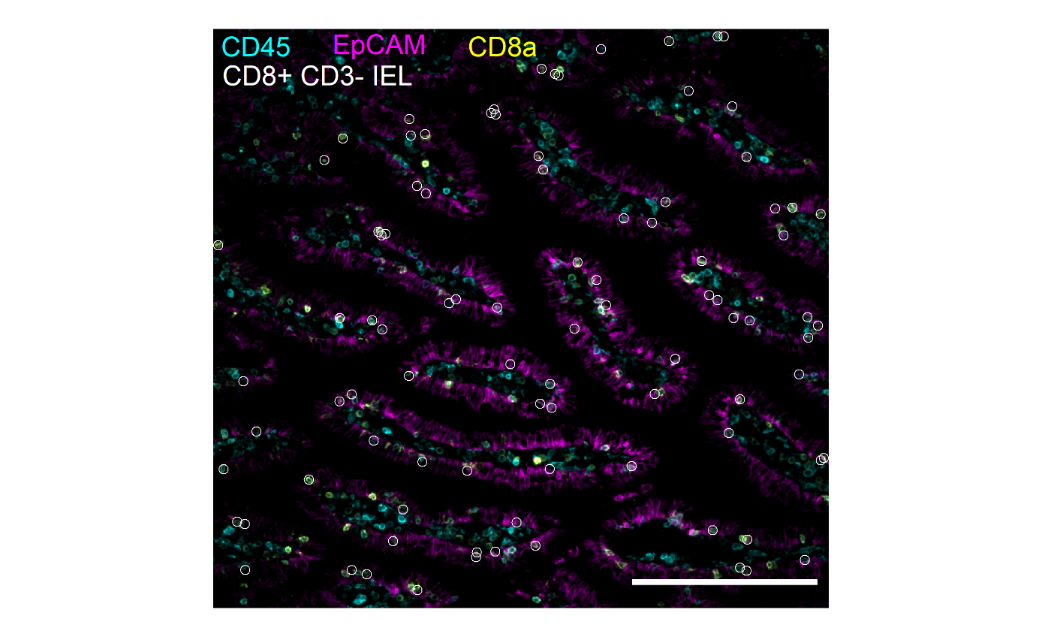

**Supplementary Fig. 6:** IF overlay showing cells of the CD8+ CD3- IEL cluster in a representative FOV in SI villi. CD45 (Cyan), EpCAM (Magenta), and CD8a (Yellow) are overlayed and depicted on top are identified CD8+ CD3- IEL (White circles). Each white circle represents one CD8+ CD3- IEL. Scale bar represents 200 µm.

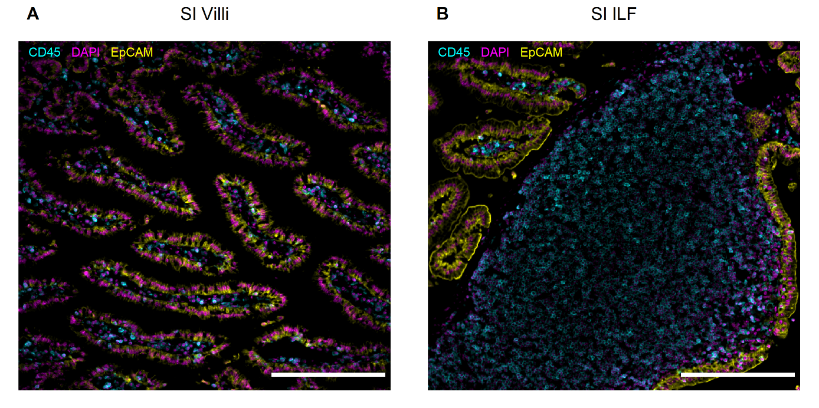

**Supplementary Fig. 7: (A)** IF overlay showing a representative FOV in SI villi stained with CD45 (Cyan), EpCAM (Yellow), and DAPI (Magenta). **(B)** IF overlay showing a representative FOV in SI ILF stained with CD45 (Cyan), EpCAM (Yellow), and DAPI (Magenta). Scale bar represents 200 µm. IF = immunofluorescence; FOV = field of view; ILF = intestinal lymphoid follicle; SI = small intestine.

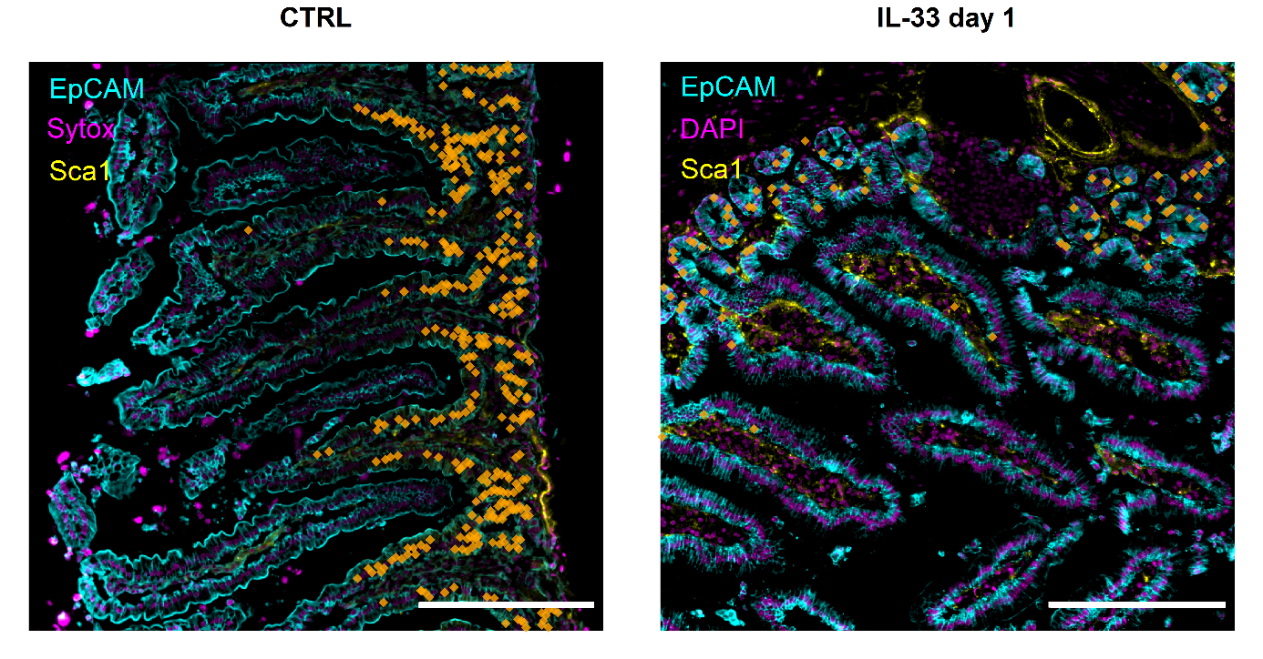

**Supplementary Figure 8:** A representative FOV of healthy SI villi and day 3 after IL-33 application showing theIF overlay of EpCAM (Cyan), DAPI (Magenta), and Sca1 (Yellow). Cells of the epithelia II cluster are superimposed (Orange dots) on the IF overlay. Each dot represents one annotated cell. Scale bar represents 200 µm. FOV = field of view.

**Supplementary Figure 9:**